Question1:
#include <stdio.h>
int main() {
char str[100];
char vowels[] = "aeiouAEIOU";
int count = 0;
int i, j;
printf("Enter a string: ");
scanf("%s", str);
for (i = 0; str[i] != '\0'; ++i) {
for (j = 0; vowels[j] != '\0'; ++j) {
if (str[i] == vowels[j]) {
count++;
break;
}
}
}
printf("Number of vowels: %d\n", count);
return 0;
}
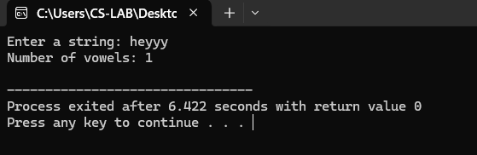
Question2:
#include<stdio.h>
#include<string.h>
int main(){
char temp,org[100],str[100];
printf("enter a string:");
scanf("%s",str);
int i,flag,n=strlen(str);
strcpy(org,str);
for(i=0;i<n/2;i++){
temp=str[i];
str[i]=str[n-1-i];
str[n-1-i]=temp;
}printf("\n org=%s, str=%s ",org,str);
for (int i = 0; i < n; i++) {
if (str[i] != org[i]) {
flag = 0;
break;
}
}
if (flag == 1) {
printf("\nIt is a palindrome.\n");
} else {
printf("\nIt is not a palindrome.\n");
}
return 0;
}
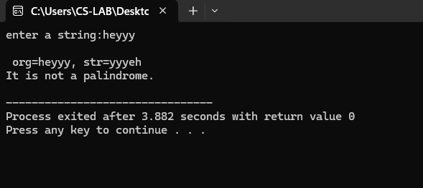
Question3:
#include <stdio.h>
int main() {
char str[100], ch;
int count = 0, i;
printf("Enter a string: ");
scanf("%s", str);
printf("Enter a character to find its frequency: ");
scanf(" %c", &ch);
for (i = 0; str[i] != '\0'; ++i) {
if (ch == str[i]) {
count++;
}
}
printf("Frequency of '%c' in the string is: %d\n", ch, count);
return 0;
}
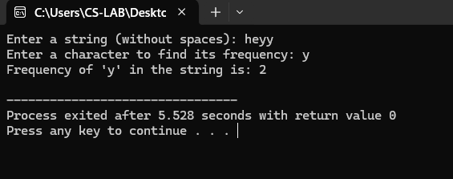
Question4:
#include <stdio.h>
#include <string.h>
int main() {
char str1[50], str2[50], str3[100];
int len, cmp_result;
printf("Enter a string for length calculation: ");
scanf("%s", str1);
len = strlen(str1);
printf("Length of the string is: %d\n", len);
char source[] = "Hello";
char destination[20];
strcpy(destination, source);
printf("Copied string: %s\n", destination);
char first[50] = "Program";
char second[] = "ming";
strcat(first, second);
printf("Concatenated string is: %s\n", first);
printf("Enter string 1 for comparison: ");
scanf("%s", str2);
printf("Enter string 2 for comparison: ");
scanf("%s", str3);
cmp_result = strcmp(str2, str3);
if (cmp_result == 0) {
printf("The strings are equal.\n");
} else if (cmp_result > 0) {
printf("String 1 is greater than String 2.\n");
} else {
printf("String 1 is less than String 2.\n");
}
return 0;
}
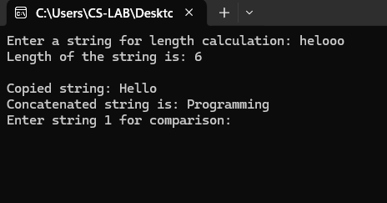
Question5:
#include<stdio.h>
int main(){
char str[50];
printf("enter a string:");
scanf("%s",str);
int i,count=0;
for(i=0;str[i]!='\0';i++){
count++;
}printf("length of string = %d",count);
return 0;
}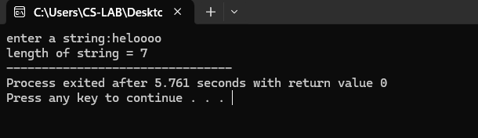
#include <stdio.h>
int main() {
char source[] = "string copy";
char destination[30];
int i = 0;
while (source[i] != '\0') {
destination[i] = source[i];
i++;
}destination[i] = '\0';
printf("Source string: %s\n", source);
printf("Destination string: %s\n", destination);
return 0;
}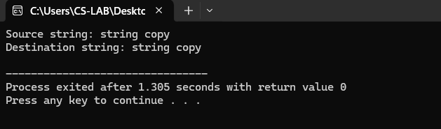
#include<stdio.h>
int main(){
char str1[]="hello";
char str2[]="hey",result[50];
int i=0,j=0;
while(str1[i]!='\0'){
result[i] = str1[i];
i++;
}
while (str2[j] != '\0') {
result[i] = str2[j];
i++;
j++;
}
result[i] = '\0';
printf("Concatenated string: %s\n", result);
return 0;
}
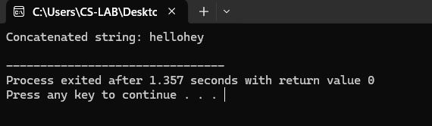
#include <stdio.h>
int main() {
char str[100];
char temp;
int i, j, length = 0;
printf("Enter a string to reverse: ");
scanf("%s", str);
while (str[length] != '\0') {
length++;
}
for (i = 0, j = length - 1; i < j; i++, j--) {
temp = str[i];
str[i] = str[j];
str[j] = temp;
}
printf("Reversed string: %s\n", str);
return 0;
}
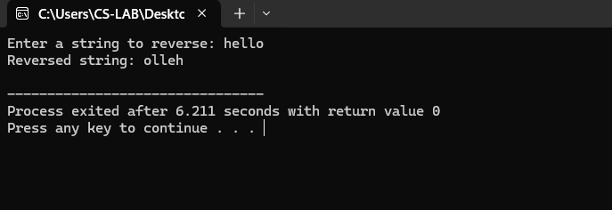
#include <stdio.h>
int main() {
char s[100];
int i = 0;
printf("Enter a string to convert to lowercase: ");
scanf("%s", s);
while (s[i] != '\0') {
if (s[i] >= 'A' && s[i] <= 'Z') {
s[i] = s[i] + 32;
}
i++;
}
printf("Lowercase string: %s\n", s);
return 0;
}
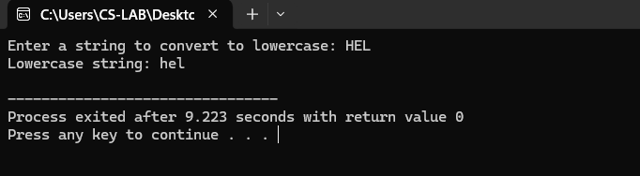
#include <stdio.h>
int main() {
char s[100];
int i = 0;
printf("Enter a string to convert to uppercase: ");
scanf("%s", s);
while (s[i] != '\0') {
if (s[i] >= 'a' && s[i] <= 'z') {
s[i] = s[i] - 32;
}
i++;
}
printf("Uppercase string: %s\n", s);
return 0;
}
